

**CSC1310: lab 7**

Costume Inventory Data Stored in a **Hash Table**

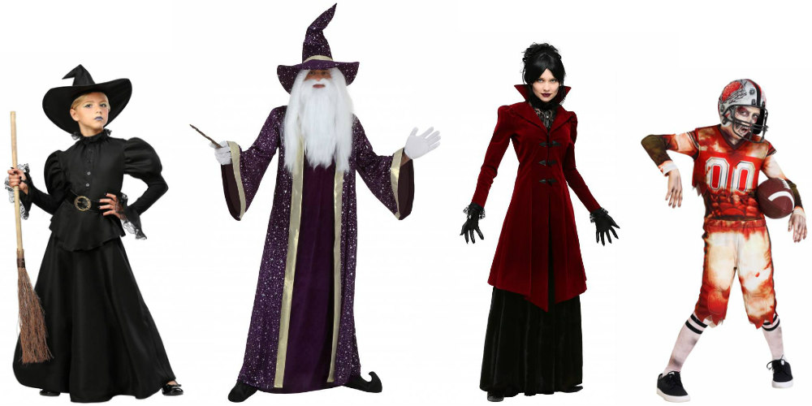

# what should this program do? (specifications)

Complete the program that will allow the user to enter data on 10 Halloween costumes. The program will create Costume objects and then store the Costume objects in a Hash Table. The **Costume ID will be the key** and **a pointer to the Costume object will be the value**.

You are given **Lab7.cpp** but you will need to change “YOU!!!” in the comment block at the top to be your name. You shouldn’t make any other changes to this code!

You are also given **HashEntry.h** and **Costume.h** and you should not have to make any changes to these files at all.

You will need to write **HashTable.h**, which implements the HashTable class. This should **NOT** be a template class. Your HashTable class should resolve collisions by **CHAINING** and should use the HashEntry class for the linkedlist nodes. Make sure to put a comment block at the top of this file with the title, author (you), date, and purpose.

# What to turn in

* Lab7.cpp
* HashEntry.h
* HashTable.h
* Costume.h

## Sample Output One

**Hello.**

**What size is the table? 4**

**\*\*\*\*\*COSTUME 1\*\*\*\*\***

**COSTUME ID: 12**

**NAME: Ghost**

**PRICE: $3.44**

**BUCKET 0**

**\*\*\*\*\*COSTUME 2\*\*\*\*\***

**COSTUME ID: 77**

**NAME: Zombie**

**PRICE: $9.99**

**BUCKET 1**

**\*\*\*\*\*COSTUME 3\*\*\*\*\***

**COSTUME ID: 32**

**NAME: Pirate**

**PRICE: $2.33**

**BUCKET 0**

**\*\*\*\*\*COSTUME 4\*\*\*\*\***

**COSTUME ID: 9**

**NAME: Vampire**

**PRICE: $9.00**

**BUCKET 1**

**\*\*\*\*\*COSTUME 5\*\*\*\*\***

**COSTUME ID: 1**

**NAME: Ghoul**

**PRICE: $87.65**

**BUCKET 1**

**\*\*\*\*\*COSTUME 6\*\*\*\*\***

**COSTUME ID: 7**

**NAME: Princess**

**PRICE: $75.65**

**BUCKET 3**

**\*\*\*\*\*COSTUME 7\*\*\*\*\***

**COSTUME ID: 94**

**NAME: Willy Wonka**

**PRICE: $2.98**

**BUCKET 2**

**\*\*\*\*\*COSTUME 8\*\*\*\*\***

**COSTUME ID: 33**

**NAME: Dwarf**

**PRICE: $1.24**

**BUCKET 1**

**\*\*\*\*\*COSTUME 9\*\*\*\*\***

**COSTUME ID: 6**

**NAME: Witch**

**PRICE: $7.68**

**BUCKET 2**

**\*\*\*\*\*COSTUME 10\*\*\*\*\***

**COSTUME ID: 5**

**NAME: Werewolf**

**PRICE: $95.67**

**BUCKET 1**

**HERE IS THE TABLE:**

**----------**

**----> 12, Ghost----> 32, Pirate**

**----> 77, Zombie----> 9, Vampire----> 1, Ghoul----> 33, Dwarf----> 5, Werewolf**

**----> 94, Willy Wonka----> 6, Witch**

**----> 7, Princess**

**----------**